**Learning Outcomes**

1. Simple ListView Control
2. Understanding ListActivity and ArrayAdapter

**ListActivity**

Android includes built-in ListActivity that you can use without defining any custom layout XML or code. The ListActivity class automatically creates a ListView and exposes a ListAdapter property to supply the row views to display via an adapter.

**SimpleListItem1**

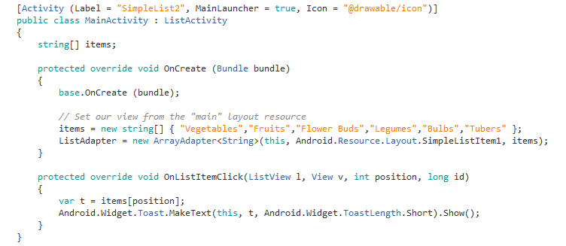

**Points to Note**

Inheriting your main activity as a ListActivity

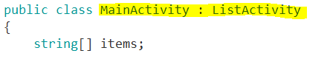

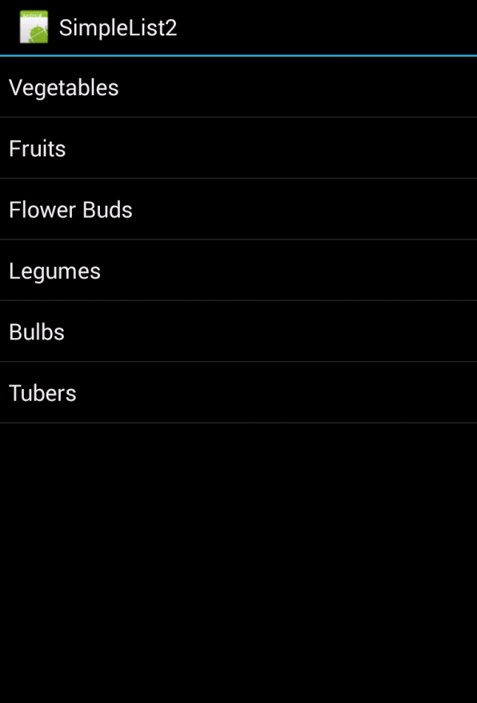

**Variations**



**For a Single Selected Item**

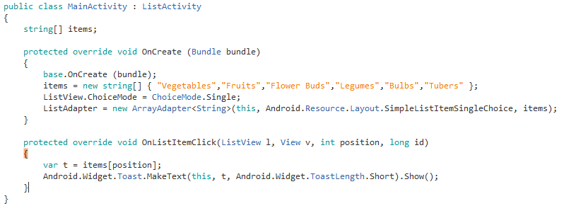

Note the difference



**For Multiple Selection**

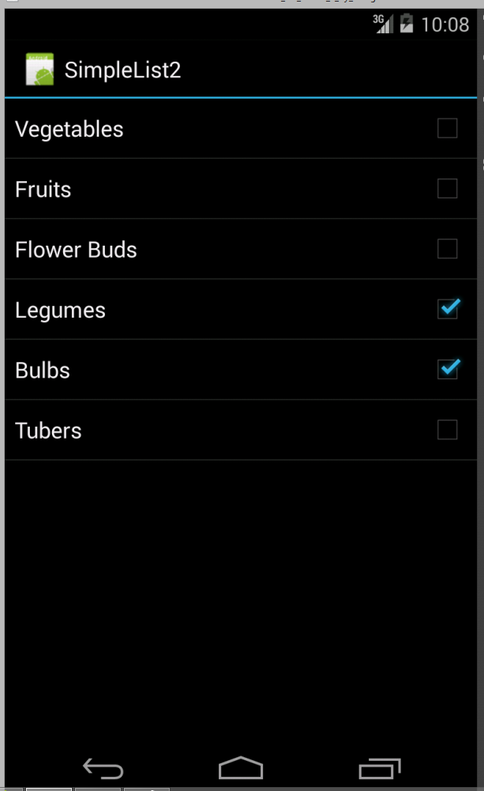

**Modify the code as follows**

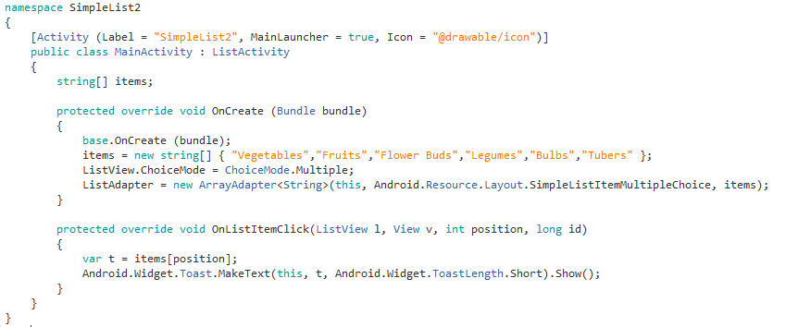

**Simple GroceryList App**

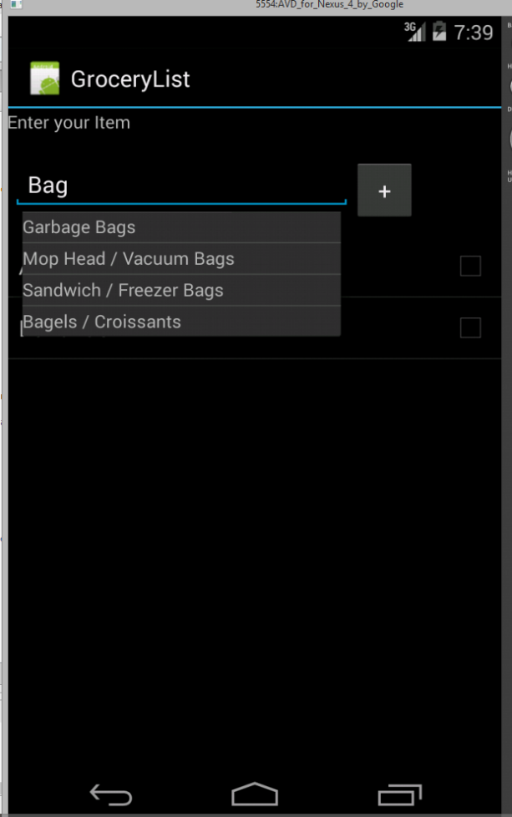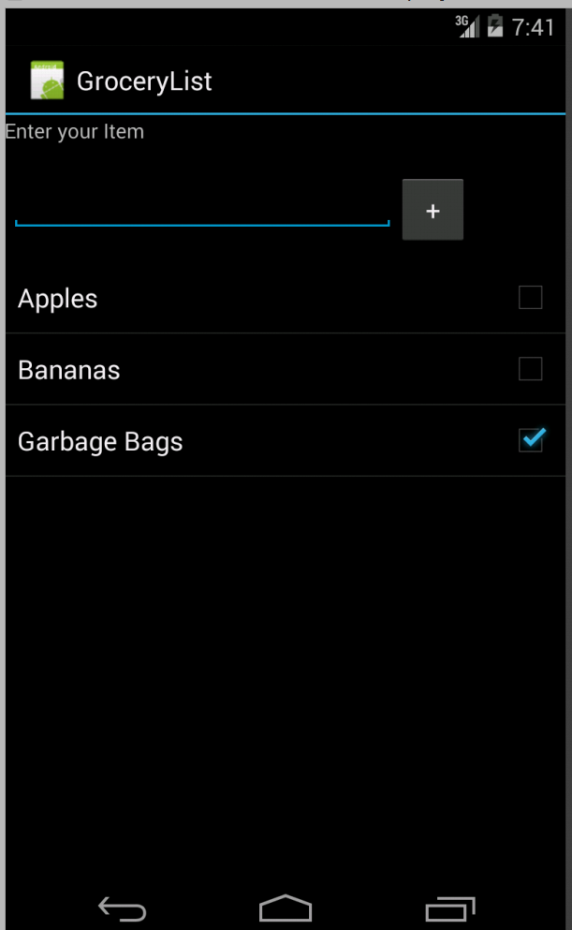

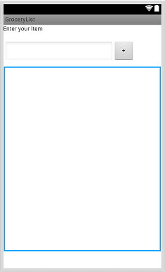

Label, autocomplete textbox, button and a listview

*Add your grocery Items in Strings.xml*

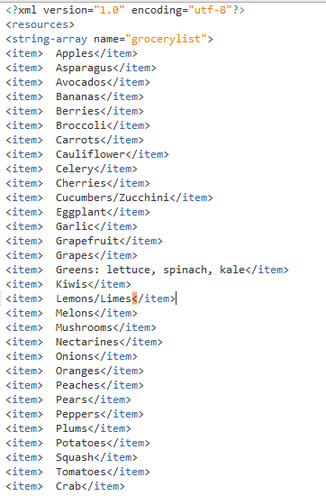

**Code**

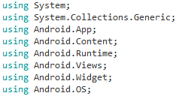

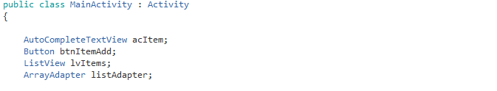

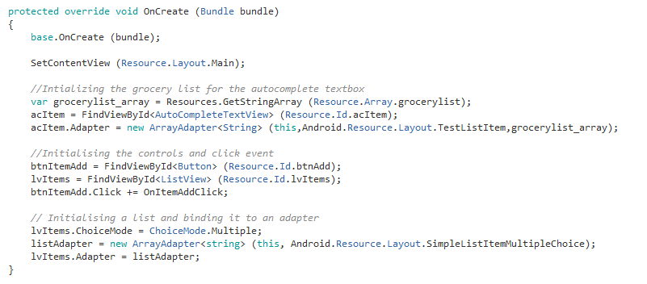

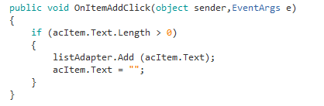

**Send Text Message to Contacts (Bulk Texting)**

In this app the user can send a text to multiple users. The app allows you to select a number of users and send them a text.

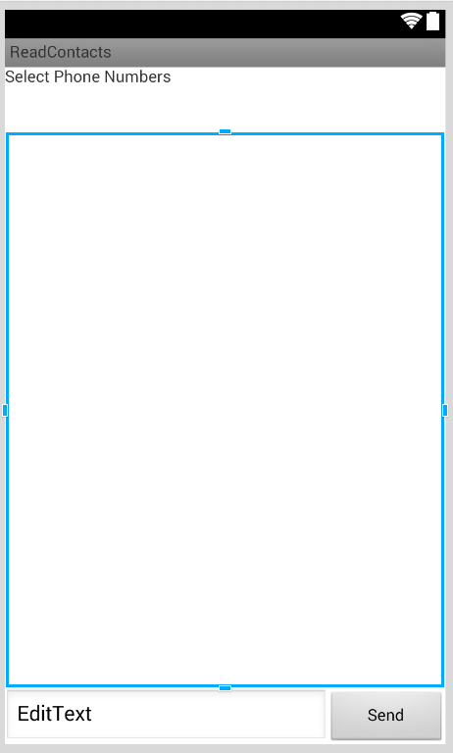

Permission required are SendSMS and Read Contacts. The permissions are set in the AndroidManifest.xml file.

In Xamarin you can do it via Project Options.

Go to Project -> (Your Project Name) Options

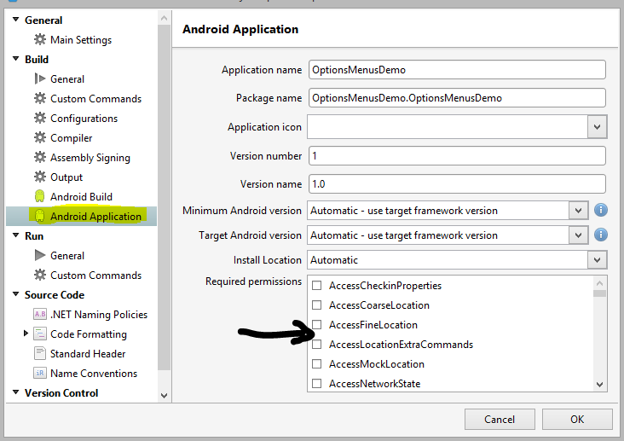

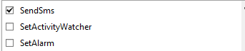



Need to add the Xamarine.Mobile component to be able to read contacts of your phone.

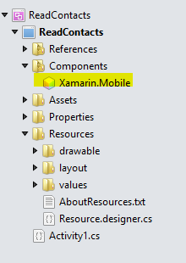

Add the appropriate using directives

